AWS Task-3

Task Description:

- Create a S3 bucket, with no public access and upload files to the bucket & view the logs using cloudwatch for the uploaded files.

- Launch two ec2-instances and connect it to a application load balancer, where the output traffic from the server must be an load balancer IP address

Techstacks needs to be used :

- AWS S3
- AWS EC2
- AWS LoadBalancer

OUTPUT

#!/bin/bash
sudo apt-get update -y
sudo apt-get install -y apache2
sudo systemctl start apache2
sudo systemctl enable apache2
echo "<h1>AWS Task 2: Ubuntu Web Server is Live</h1>" | sudo tee /var/www/html/index.html
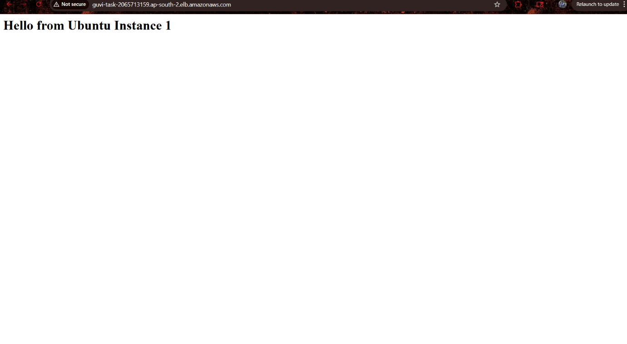
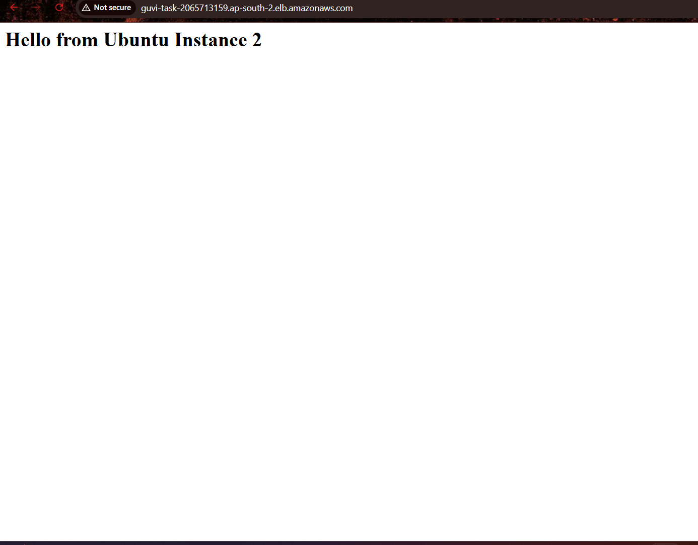

2
